

CT BHP
WEB-BASED REGISTRATION SYSTEM

USER MANUAL

Table of Contents

Log In Screen 3
Main Menu 3
Consumer Search 4
Face Sheet 5
Custom Form List 5
Custom Form History 6
Provider’s location 7
Level of Care 8
CT BHP Service Registration 9
Ambulatory Detoxification 25
Methadone Maintenance 27
Psychological/Neurological Testing 28

Log In Screen
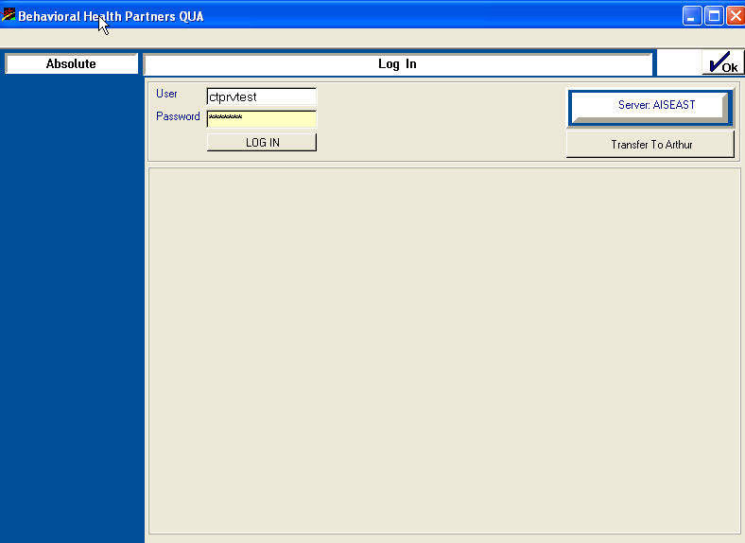

Note: First time Users will enter their assigned ID in the User and Password fields. After clicking OK you will be prompted to create a new password.

- Enter ID and Password* and then click OK

Main Menu

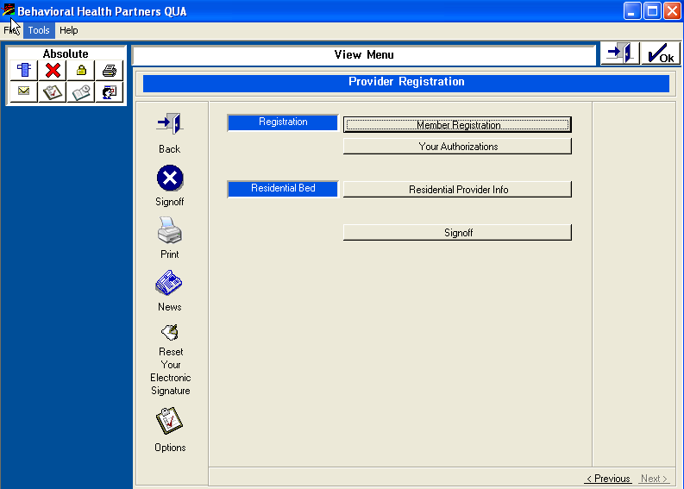

Note: By clicking the “Your Authorization” button, users will be able to view all completed registrations. By double clicking on any of the listings, users can view the authorization number and the fields completed on the initial registration.

- Click on “Member Registration” to begin the registration process.

Consumer Search

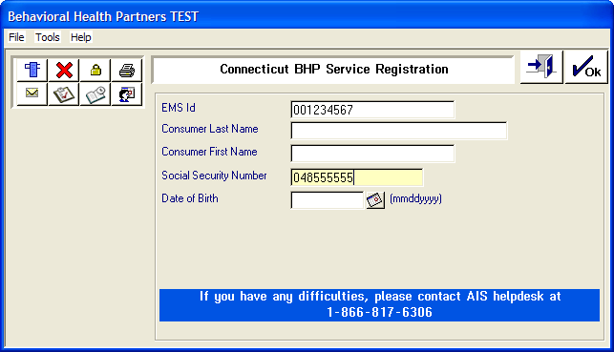

Note: *Due to possible spelling discrepancies, the CT BHP does not suggest merely using the member’s name as a search field.

- To search for the CT BHP member, Enter the consumer/member’s EMS Id (Member’s 9 digit Medicaid ID starting with 00…) and either the member’s social security number or date of birth*.

- Click OK
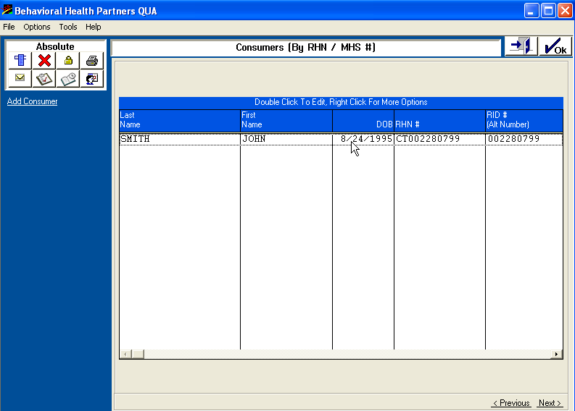

Note: The registration system includes a CT before the member’s EMS ID. This is only for internal purposes and the CT prefix should not be included when billing or verifying eligibility.

- Double click on the member listing. If no listing displays, click the back button and try another search criteria (i.e. EMS ID# & Date of Birth or Last Name.)

Face Sheet

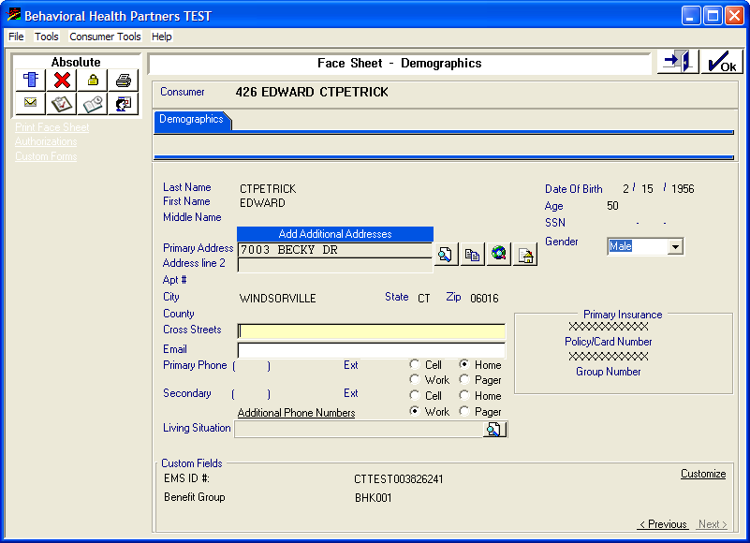
Please Note: This screen cannot be edited by a provider.
- Left side links
Print Face sheet – provider can print this screen
Authorizations – provider can view all of his/her authorizations for this consumer/member.
Custom Forms – provider can access the BHP Service Registration forms or Psychological/Neurological Testing forms.

- Click Custom Forms
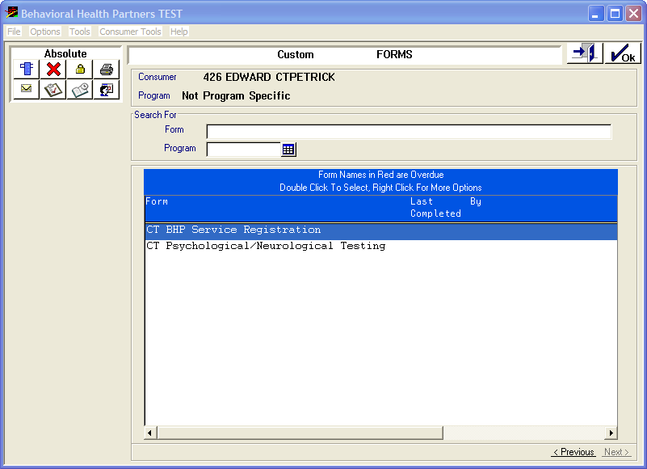

- Double click on the type of registration you are completeing
  - CT BHP Service Registration
  - CT Psychological/Neurological Testing

Custom Form History

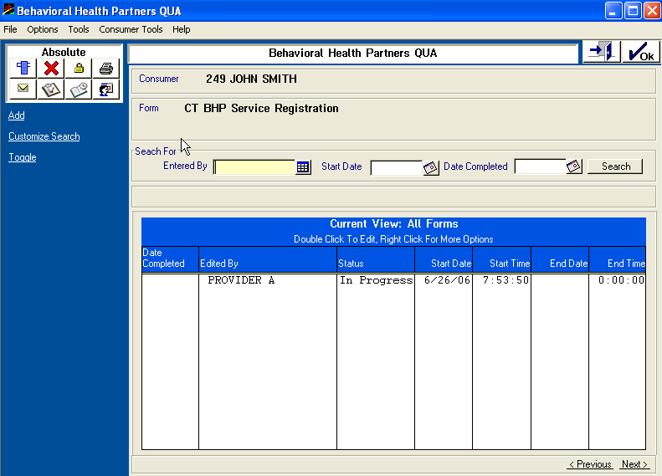

- To add/create a new registration, click “Add” on the left-side link

Please note: This screen also displays entries of registrations the user may have entered for this client previously (circled). To view a previous registration:
  - In Progress – A registration was started and never completed. User can double click on entry to complete the registration.
  - Completed – right click and view
  - To delete – User can delete multiple registrations that were previously In Progess by right clicking on the line and selecting delete.

Provider’s location
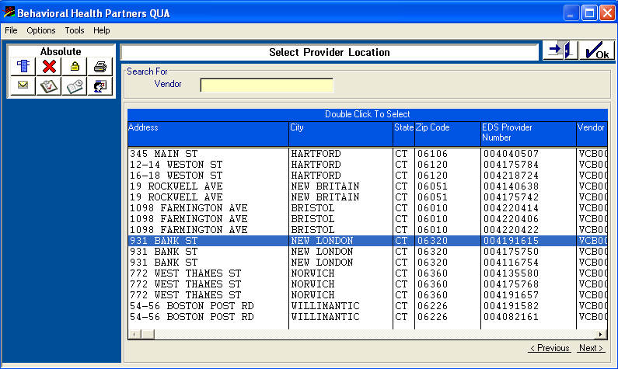

- Double click on the location where the services are being rendered. Ensure that you are also choosing the correct EDS Provider # (CMAP ID – 9 digit provider number beginning with 00…)

Please note: Medicaid providers are enrolled by their type and specialty. Providers may have one address with multiple EMS ID #’s (i.e. Mental Health Clinic ID#, Alcohol and Drug Center ID#, Methadone Clinic ID#, General Hospital – Inpatient ID#, General Hospital – Outpatient ID#, etc.)
  - For proper registration and claims reimbursement, users must choose the correct location where the services are being rendered.
  - Providers should ensure that the users of the registration system will be selecting the correct EMS ID#’s for the correct service location.

Level of care
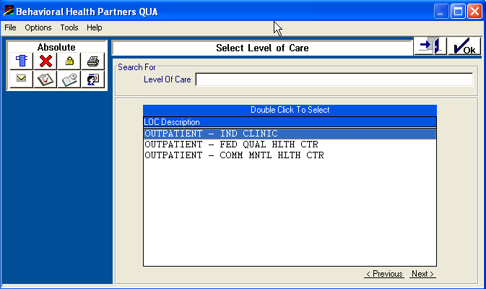

- Double click on the appropriate level of care.

Please note: Based on provider type and services offered, other choices could include:
    - Family Support Teams (FST) – Home
    - Family Support Teams (FST) – Other
    - Psych Testing – Ind Clinic
    - Psych Testing – Fed Qual Hlth Ctr
    - Psych Testing – Comm Mntl Hlth Ctr
    - Methadone Maintenance – Ind Clinic
    - Methadone Maintenance – Fed Qual Hlth Ctr
    - Methadone Maintenance – Comm Mntl Hlth Ctr
    - Ambulatory Detox – Freestanding- O/P Hosp
    - Ambulatory Detox – Freestanding- Other

CT BHP Service Registration – Page 1

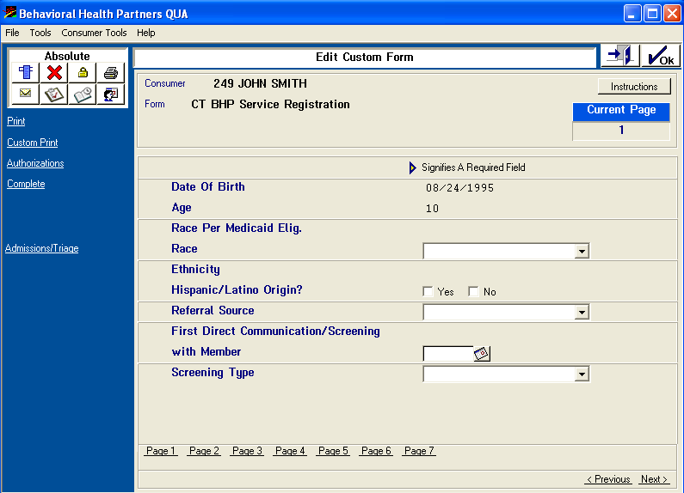

- The following fields on Page 1 will need to be completed:

  - Race: Choose selection from the drop down menu. (i.e. American Indian/Alaskan, Asian, Black/African American, Native Hawaiian/Pacific, White

  - Hispanic/Latino Origin: Select Yes or No

  - Referral Source: Choose selection from the drop down menu. (i.e. Self/Family Member, PCP/Medical Provider, Step Down Intermediate LOC, Step Down Inpatient LOC, Other BH Provider, School, Comm. Collaborative, CT BHP ASO, DCF, DMR, DMHAS, Hospital Emergency Dept, Managed Service System, Court-ordered, Other Legal, Other)

  - First Direct Communication/Screening with Member
    - Enter date or use the calendar link to the right of the field to select date

- When the above fields are complete: Click OK, Next (Bottom right of screen) or
Page 2 (bottom left of screen)

CT BHP Service Registration - Page 2

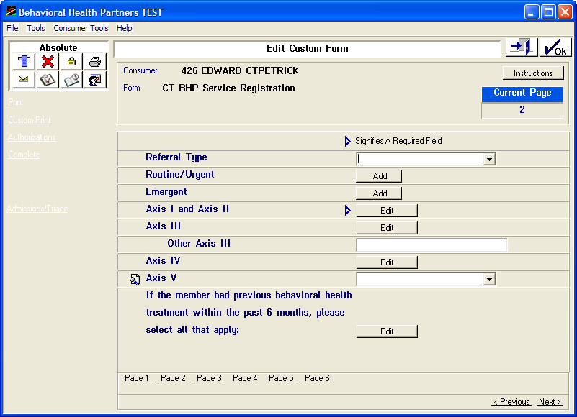

- The following fields on Page 2 will need to be completed:

  - Referral Type: Choose selection from the drop down menu. (i.e. Routine, Urgent, Emergent)

  - If Routine or Urgent Click Add and enter the following: 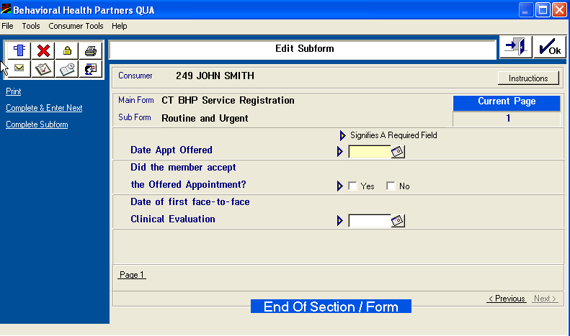
    - Date Appointment Offered
      - Enter date or use the calendar link to the right of the field to select date
    - Did the Member Accept the Offered Appointment?
      - Select Yes or No
    - Date of first face-to-face Clinical Evaluation:
      - Enter date or use the calendar link to the right of the field to select date
- Click OK

CT BHP Service Registration - Page 2 (cont.)

  - If Emergent Click Add and enter the following:
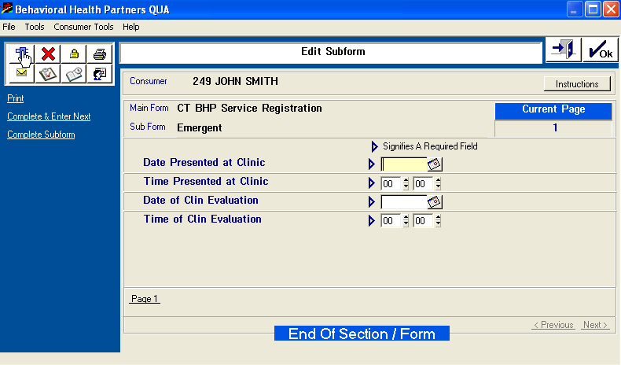
    - Date and Time Presented at Clinic
      - Enter date or use the calendar link to the right of the field to select date and enter time.
    - Date and Time of Clinical Evaluation
      - Enter date or use the calendar link to the right of the field to select date and enter time.
- Click Complete Subform

- Axis I & II - Click on Edit

CT BHP Service Registration - Page 2 (cont.)

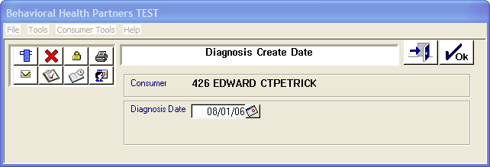

- Enter Date of Diagnosis Determination (mmddyyyy) or use calendar link on right.
- Click OK

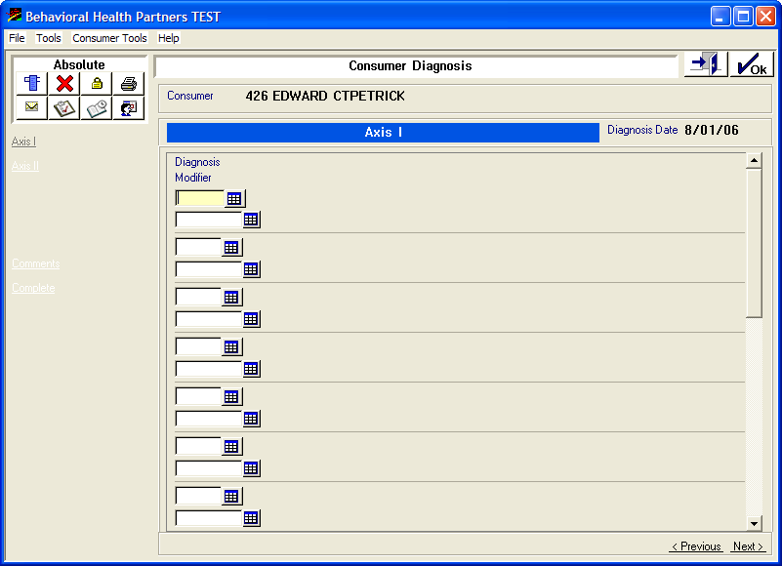

- Click the table next to the diagnosis field

CT BHP Service Registration - Page 2 (cont.)

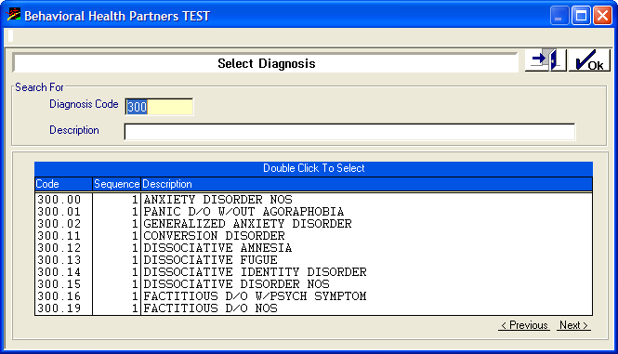

- Enter the diagnosis code, hit enter on your keyboard, then double click on appropriate code.

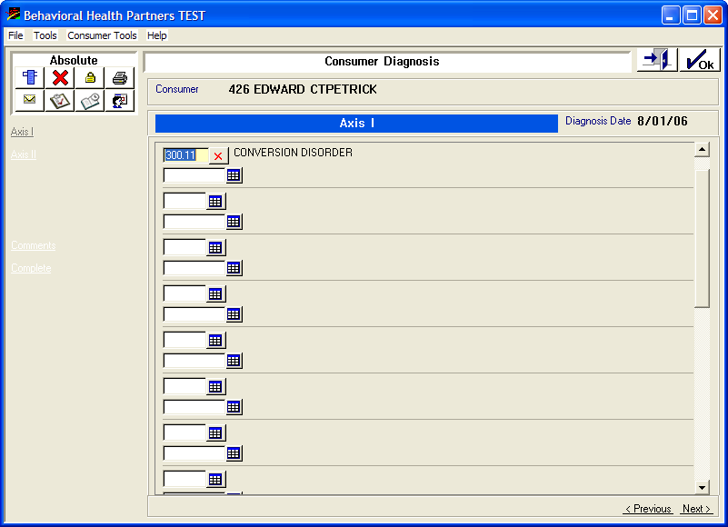

CT BHP Service Registration - Page 2 (cont.)

- Click the table next to the modifier field.

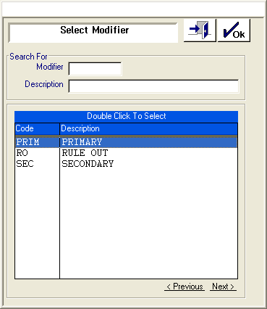

- Double click on appropriate modifier (i.e. primary).

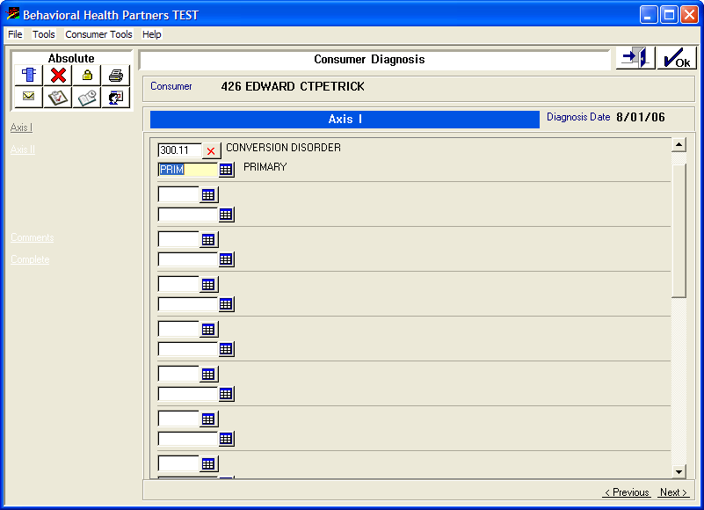

- Click on Axis II and repeat same steps of entering Axis I.
- Click OK

CT BHP Service Registration - Page 2 (cont.)

Click Edit for Axis III

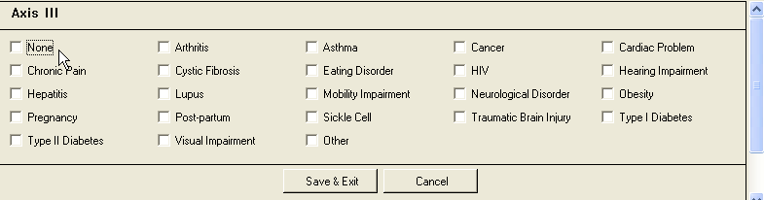

Select all that apply and then click Save & Exit

If “Other” is chosen, the Other Axis III field needs to be completed on Page 3.

CT BHP Service Registration - Page 2 (cont.)

Axis IV - Click Edit and complete free text field below.
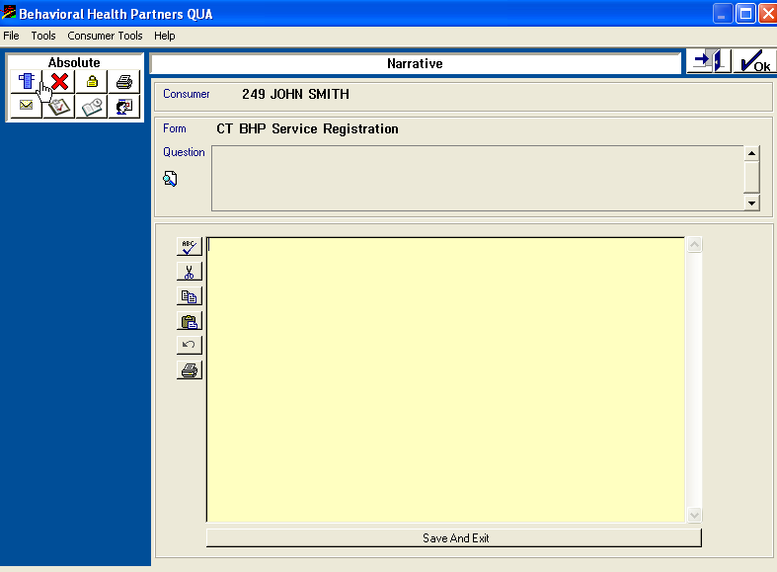

Axis V – Choose the appropriate number on the GAF Score Scale from the drop down menu.

Note: A Help menu with GAF scale definitions are available by clicking the magnifying glass icon to the left of Axis V
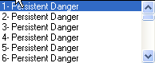

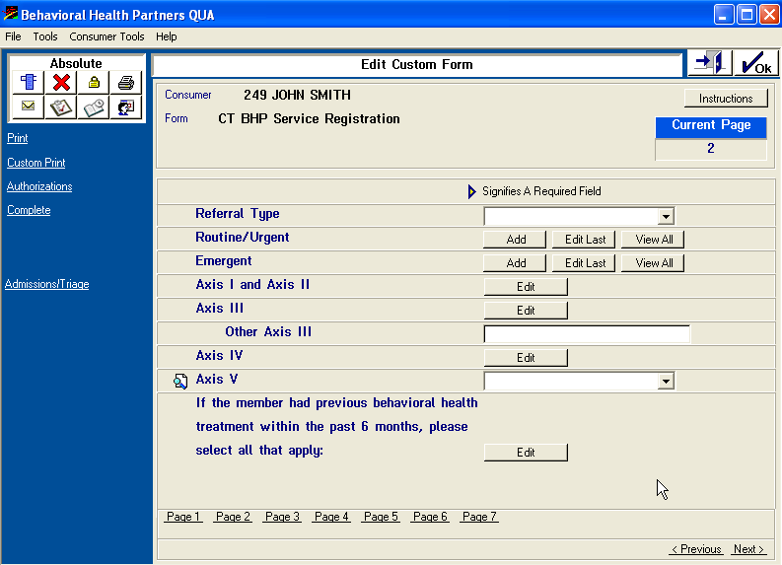

Click Edit

CT BHP Service Registration - Page 2 (cont.)

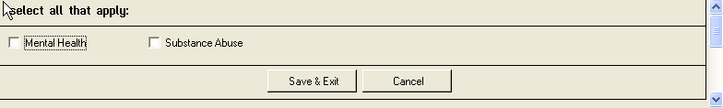

Choose all that apply and click Save & Exit

Click on Page 3

CT BHP Service Registration - Page 3

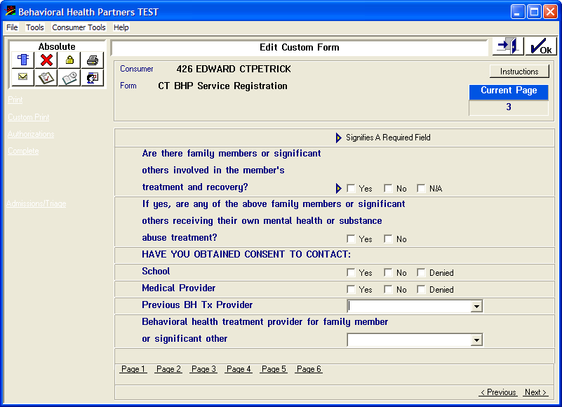

- Click and select answers to all questions on Page 3

- The last 2 questions will require the use of drop down menus

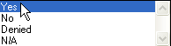

- Click on Page 4

CT BHP Service Registration - Page 4

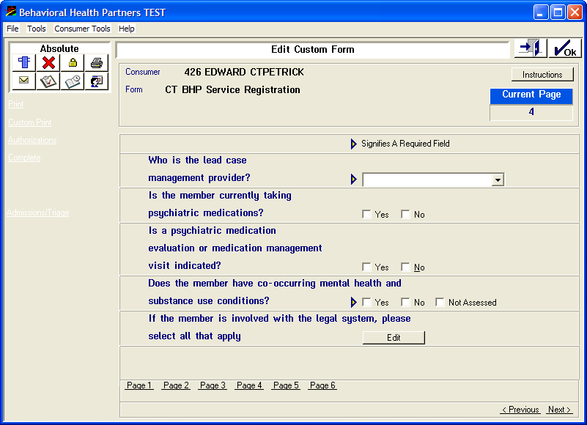

Complete all questions on Page 4:

Who is the lead case management provider?
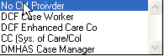

Please note: If the member does not specifically have one of the above leads for the member’s case management, choose No CM Provider

  - Is the member currently taking psychiatric medications?
  - Is a psychiatric medication evaluation or medication management visit indicated?
  - Does the member have co-occuring mental health and substance abuse conditions?
  - If the member is involved with the legal system – Click Edit
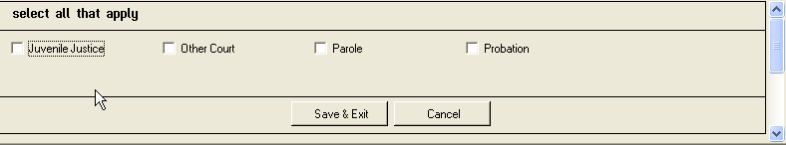

- Click Page 5 (bottom of screen)

CT BHP Service Registration – page 5

- The Federal Reporting questions only displays if the consumer/member is between the ages of 0-17 years old.

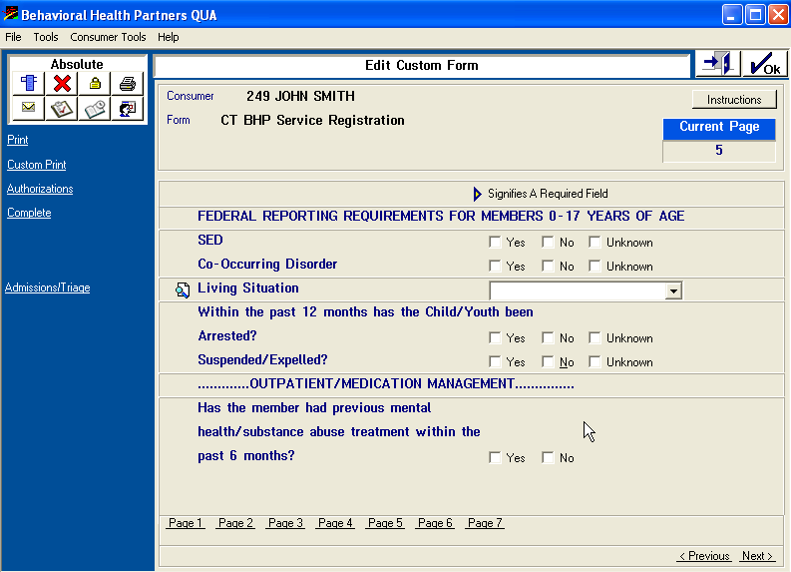

FIELDS:

SED: Seriously/Severely Emotionally Disturbed

Living Situation -

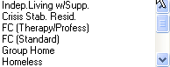

CT BHP Service Registration

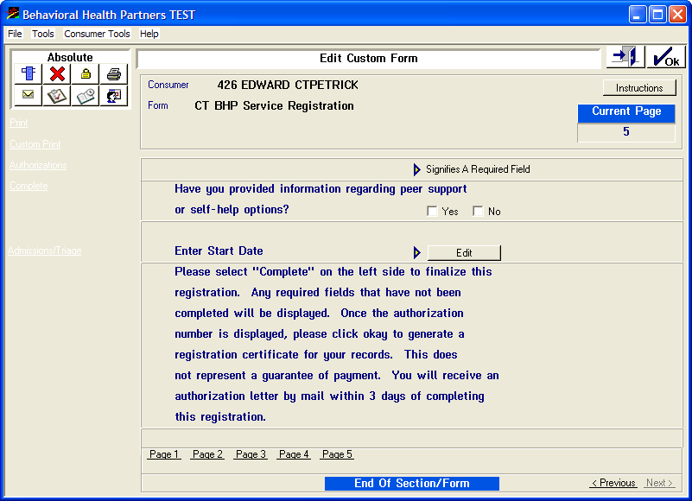

- Enter Start Date: Click Edit

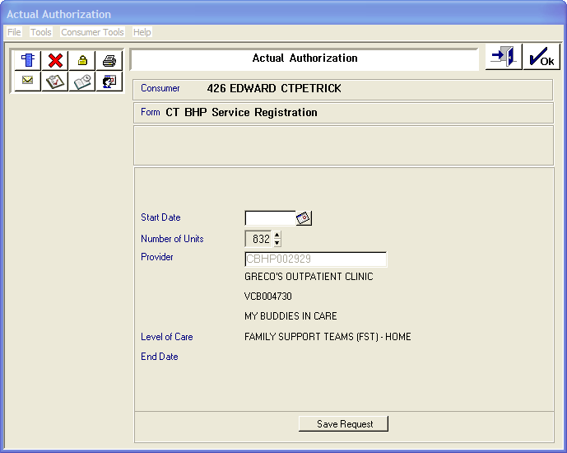

- Enter Start Date and then click Save Request
NOTE: If a text box pops up stating “Contact the CT BHP” or “Authorizations Overlap” the member’s registration has been previously entered and completed. (See page 24* )

CT BHP Service Registration

- Click Complete
- The following window will appear after registration is complete. The EDS authorization can now be notated in provider’s system and/or member file.

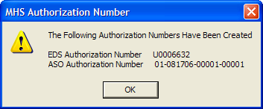

- A hard copy authorization letter for this registered service will be also be generated and mailed to the provider.
- Click OK
IMPORTANT:

EDS Authorization number (U + 7 digits): Authorization number confirming registration was successful. This EDS authorization should be entered on all claims for this member for dates of service Sept 1st and ongoing until the approved units are utilized or until a concurrent review is performed for additional units.

ASO Authorization Number: Internal Authorization number for the CT BHP. This number should never be used for billing purposes.

CT BHP Service Registration

- If you wish to enter an additional authorization or to *verify completed authorizations, click the menu icon and then click “Menu” on the Navigational pop-up window. This will return the user to the starting menu screen of the CT BHP web registration system. Choose Member Registration to begin another registration or *Your Authorizations to verify completed authorizations.

Ambulatory Detoxification
Note: All questions/fields for Ambulatory Detoxification/Methadone Maintenance/Psychological & Neuro Psychological Testing are required and need to be completed. Fields with drop-down menus are indicated below.

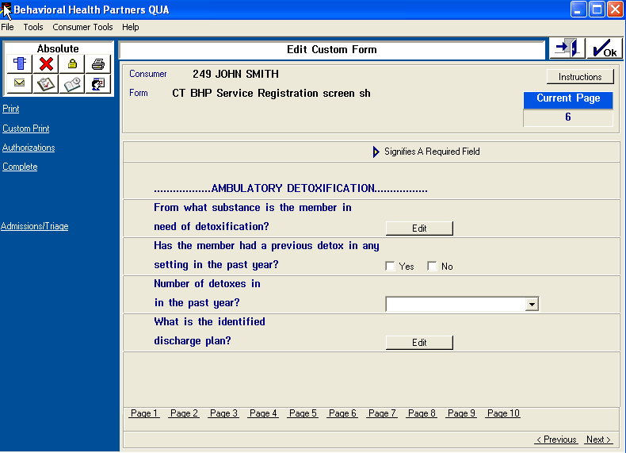

FIELDS:

From what substance is the member in need of detoxification?
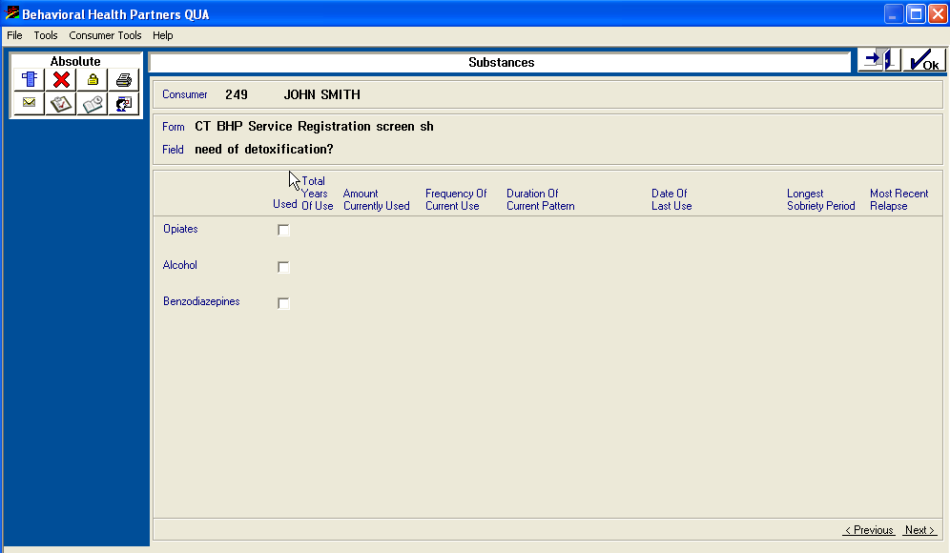

Ambulatory Detoxification (cont.)

Number of detoxes in the past year?
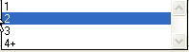

What is the identified discharge plan?

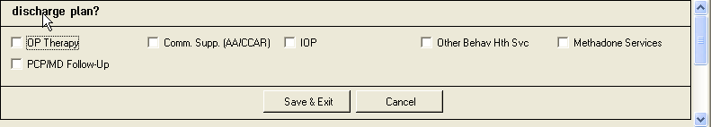

Methadone Maintenance
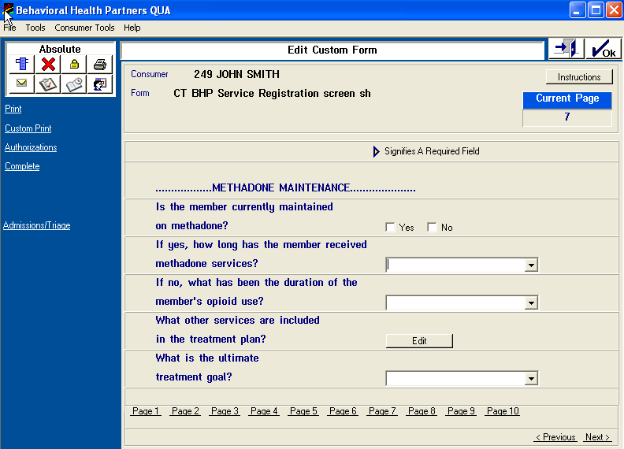

FIELDS:
If yes, how long has the member received methadone services?
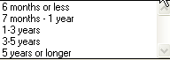

If no, what has been the duration of the member’s opioid use?
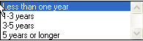

Continuation of Methadone Maintenance

What is the ultimate treatment goal?

Psychological/Neurological Testing
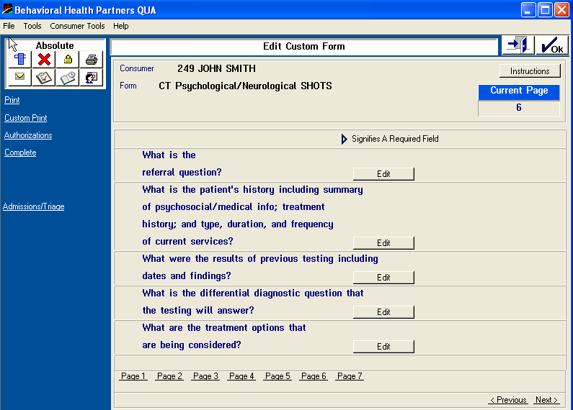

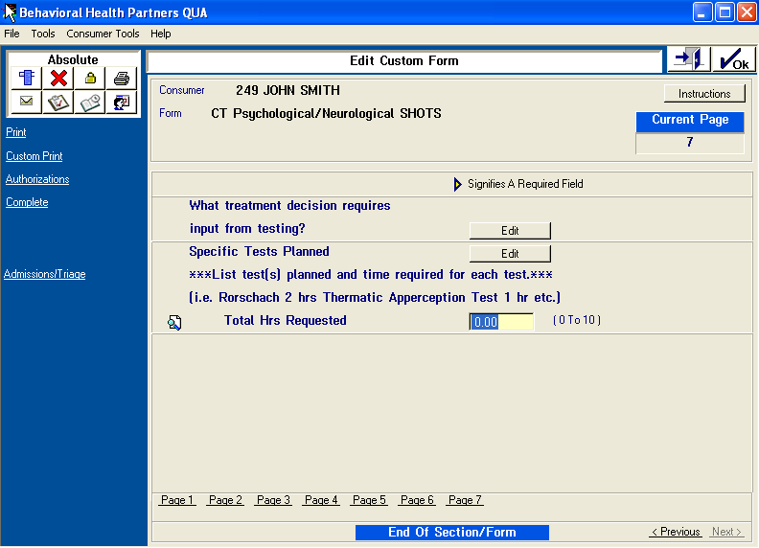

- The Psychological/Neurological Testing form is separate from the CT BHP Service Registration form.
- The basic questions (across all levels of care) are also in this form.
- All questions are long narrative fields.

