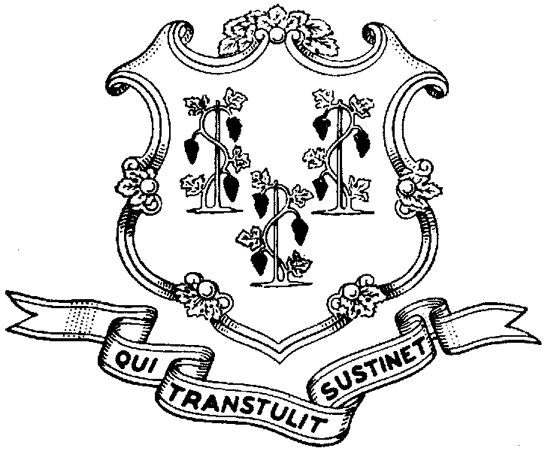
Behavioral Health Partnership Oversight Council
Legislative Office Building Room 3000, Hartford CT 06106
(860) 240-0321 Info Line (860) 240-8329 FAX (860) 240-5306
www.cga.ct.gov/ph/medicaid

February 21, 2006

Patricia Wilson-Coker, Commissioner
Department of Social Services
25 Sigourney Street
Hartford, CT 06106

Dear Commissioner Wilson-Coker:

We are writing as the Behavioral Health Partnership Oversight Council co-chairs and Council representative of the legislative Public Health Committee to request the Department’s assistance in resolving outstanding claims payment issues for behavioral health care services rendered to HUSKY members prior to January 1, 2006.

There was lengthy discussion at the most recent Oversight Council meeting about the critical importance of bringing providers and HUSKY Managed Care Organizations (MCOs) together regarding this issue. There was much agreement that, without the Department’s intercession, unpaid claims disputes among the parties are not likely to be resolved.

The scope of the problem is of such magnitude (possibly as high as $12 million) that it threatens to thwart our efforts to keep all parties (particularly service providers) focused on assuring the success of the fledgling Partnership.

We request that the Department immediately take the following steps:

- Solicit and analyze a sample of disputed claims from each MCO to determine the reasons why such claims have not been paid;
- Identify a lead person at each MCO with whom providers can work to resolve disputed claims;
- Require of each MCO the payment of disputed claims that meet the following criteria:
  - claim met original timely filing standard;
  - service received authorization, when such authorization was required;
  - provider was contracted to provide the service;
  - provider supplied proof of meeting (a) – (c), including contemporaneous notations in patient record, copy of claims, etc.

I am sure you will agree with us that service providers should not be denied payment strictly on technicalities. Your department’s help will assure that such a result does not occur as the book is closed on the former behavioral health program’s business. We request to meet with the Department prior to the March 8th BHP Oversight Council meeting to hear about your plans to address the unpaid claims issues.

We thank you in advance for your assistance in this matter.

Very truly yours,

Jeffrey Walter
Co-Chair of the Council

Senator Christopher Murphy
Co-Chair of the Council

Representative Peggy Sayers
Chair, Public Health Committee

CC Michael Starkowski
David Parrella
Dr. Mark Schaeffer
State Senator Toni Harp

